**Topics: Descriptive Statistics and Probability**

1. Look at the data given below. Plot the data, find the outliers and find out $μ, σ, σ^{2}$

|  |  |
| --- | --- |
| **Name of company** | **Measure X** |
| Allied Signal | 24.23% |
| Bankers Trust | 25.53% |
| General Mills | 25.41% |
| ITT Industries | 24.14% |
| J.P.Morgan & Co. | 29.62% |
| Lehman Brothers | 28.25% |
| Marriott | 25.81% |
| MCI | 24.39% |
| Merrill Lynch | 40.26% |
| Microsoft | 32.95% |
| Morgan Stanley | 91.36% |
| Sun Microsystems | 25.99% |
| Travelers | 39.42% |
| US Airways | 26.71% |
| Warner-Lambert | 35.00% |

**Ans: -**

The following is the outlier in the boxplot: 0.9

µ (Mean) = 0.332

σ2 (Variance) = 0.028

σ (Standard deviation)= 0.169

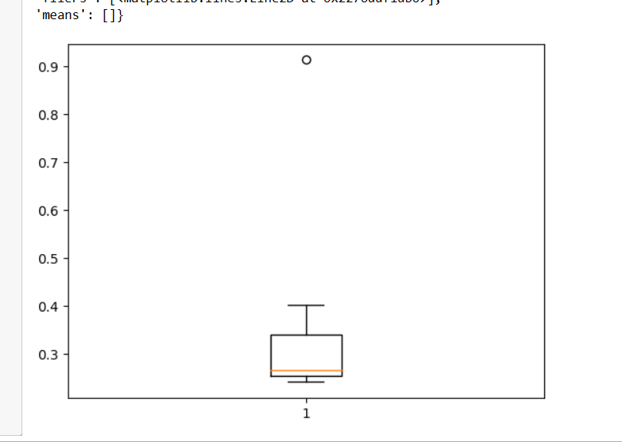

**2)**



**Answer the following three questions based on the box-plot above.**

1. **What is inter-quartile range of this dataset? (please approximate the numbers) In one line, explain what this value implies.**

**Ans: -**

Approximately (First Quantile Range) Q1 = 5 (Third Quantile Range) Q3 = 12,

Median (Second Quartile Range) = 7

(Inter-Quartile Range) IQR = Q3 – Q1 = 12 – 5 = 7

Second Quartile Range is the Median Value.

1. **What can we say about the skewness of this dataset?**

**Ans: -**

Right-Skewed median is towards the left side it is not normal distribution

1. **If it was found that the data point with the value 25 is actually 2.5, how would the new box-plot be affected?**

**Ans: -**

In that case there would be no Outliers on the given dataset because of the outlier the data had positive skewness it will reduce and the data will normal distributed.

**3.**



**Answer the following three questions based on the histogram above.**

1. **Where would the mode of this dataset lie?**

**Ans: -**

The mode of this data set lie in between 5 to 10 and approximately between 4 to 8 .

1. **Comment on the skewness of the dataset.**

**Ans: -**

Right-Skewed. Mean>Median>Mode

1. **Suppose that the above histogram and the box-plot in question 2 are plotted for the same dataset. Explain how these graphs complement each other in providing information about any dataset.**

**Ans: -**

Median in boxplot and mode in Histogram.Histogram provides the frequency distribution so we can see how many time each data point is occurring however, boxplot provides the quintile distribution i.e.50%data lies between %5.They both are right-skewed and both have outliers the median can be easily visualized in box plot where as in histogram mode is more visible.

1. **AT&T was running commercials in 1990 aimed at luring back customers who had switched to one of the other long-distance phone service providers. One such commercial shows a businessman trying to reach Phoenix and mistakenly getting Fiji, where a half-naked native on a beach responds incomprehensibly in Polynesian. When asked about this advertisement, AT&T admitted that the portrayed incident did not actually take place but added that this was an enactment of something that “could happen.” Suppose that one in 200 long-distance telephone calls is misdirected. What is the probability that at least one in five attempted telephone calls reaches the wrong number? (Assume independence of attempts.)**

**Ans: -**

IF 1 in 200 long-distance telephone calls are getting misdirected.

probability of call misdirecting = 1/200

Probability of call not Misdirecting = 1-1/200 = 199/200

The probability for at least one in five attempted telephone calls reaches the wrong number

Number of Calls = 5

n = 5

p = 1/200

q = 199/200

P(x) = at least one in five attempted telephone calls reaches the wrong number

P(x) = ⁿCₓ pˣ qⁿ⁻ˣ

P(x) = (nCx) (p^x) (q^n-x) # nCr = n! / r! * (n - r)!

P(1) = (5C1) (1/200)^1 (199/200)^5-1

P(1) = 0.0245037

1. **Returns on a certain business venture, to the nearest $1,000, are known to follow the following probability distribution**

|  |  |
| --- | --- |
| **x** | **P(x)** |
| **-2,000** | **0.1** |
| **-1,000** | **0.1** |
| **0** | **0.2** |
| **1000** | **0.2** |
| **2000** | **0.3** |
| **3000** | **0.1** |

1. **What is the most likely monetary outcome of the business venture?**

**Ans: -**

The most likely monetary outcome of the business venture is 2000$. As for 2000$ the probability is 0.3 which is maximum as compared to others.

1. **Is the venture likely to be successful? Explain**

**Ans: -**

Yes, the probability that the venture will make more than 0 or a profit

p(x>0)+p(x>1000)+p(x>2000)+p(x=3000) = 0.2+0.2+0.3+0.1 = 0.8 this states that there is a good 80% chances for this venture to be making a profit.

1. **What is the long-term average earning of business ventures of this kind? Explain**

**Ans: -**

The long-term average is Expected value = Sum (X * P(X)) = 800$ which means on an average the returns will be + 800$.

1. **What is the good measure of the risk involved in a venture of this kind? Compute this measure**

**Ans: -**

The good measure of the risk involved in a venture of this kind depends on the Variability in the distribution. Higher Variance means more chances of risk.

Var (X) = E(X^2) –(E(X))^2

= 2800000 – 800^2

= 2160000.